***CAPACITOR***

**MEMBERS:**

* MUHAMMAD ZUNIQUE (20k-0145)
* MUHAMMAD AMMAR SIDDIQUI (20k-0177)
* MUHAMMAD MUAZ ZAFAR (20k-0363)

## *CHARGE:*

# DEFINITION:

Electric charge is the physical property of matter that causes it to experience a force when placed in an electromagnetic field.

# TYPES:

 There are two types of electric charge *positive* and *negative* (commonly carried by protons and electrons respectively). Like charges repel each other and unlike charges attract each other. An object with an absence of net charge is referred to as neutral

# EXPLNATION:

Electric charge is carried by subatomic particles. In ordinary matter, negative charge is carried by electrons, and positive charge is carried by the protons in the nuclei of atoms. If there are more electrons than protons in a piece of matter, it will have a negative charge, if there are fewer it will have a positive charge, and if there are equal numbers it will be neutral. Charge is *quantized*; it comes in integer multiples of individual small units called the elementary charge, *e*, about 1.602×10−19 coulombs, which is the smallest charge which can exist freely. The proton has a charge of +*e*, and the electron has a charge of –*e*.

# UNIT:

The SI derived unit of electric charge is the coulomb (C) named after French physicist ***Charles-Augustin de Coulomb.***  Chemistry also uses the Faraday constant as the charge on a mole of electrons. The lowercase symbol *q* often denotes charge. It is denoted by Q.

# FORMULA:

***Q=I.T***

## *ELECTRIC FIELD:*

# DEFINITION:

An electric field (sometimes E-field) is the physical field that surrounds each electric charge and exerts force on all other charges in the field, either attracting or repelling them.

# IMPORTANCE:

Electric fields are important in many areas of physics, and are exploited practically in electrical technology. In atomic physics and chemistry, for instance, the electric field is used to model the attractive force holding the atomic nucleus and electrons together in atoms. It also models the forces in chemical bonding between atoms that result in molecules.

# RELATION WITH GRAVITATIONAL FIELD:

The electric field acts between two charges similarly to the way the gravitational field acts between two masses, as they both obey an inverse-square law with distance. This is the basis for Coulomb's law, which states that, for stationary charges, the electric field varies with the source charge and varies inversely with the square of the distance from the source. This means that if the source charge were doubled, the electric field would double, and if you move twice as far away from the source, the field at that point would be only one-quarter its original strength.

# SI UNIT:

The derived SI units for the electric field are volts per meter (V/m), exactly equivalent to newtons  per coulomb (N/C).

# SYMBOL:

Its symbol is ‘E’.

# FORMULA:

The magnitude of the electric field (E) produced by a point charge with a charge of magnitude Q, at a point a distance r away from the point charge, is given by the equation **E = kQ/r2**, where k is a constant with a value of **8.99 x 109 N m2/C2**.

## *ELECTRIC flux :*

# DEFINITION:

**Electric Flux**, property of an electric field that may be thought of as the number of electric lines of force (or electric field lines) that intersect a given area.

# EXPLANATION:

Electric field lines are considered to originate on positive electric charges and to terminate on negative charges. Field lines directed into a closed surface are considered negative; those directed out of a closed surface are positive. If there is no net charge within a closed surface, every field line directed into the surface continues through the interior and is directed outward elsewhere on the surface. The negative flux just equals in magnitude the positive flux, so that the net, or total, electric flux is zero. If a net charge is contained inside a closed surface, the total flux through the surface is proportional to the enclosed charge, positive if it is positive, negative if it is negative.

# SYMBOL:

It is denoted by ϕe.

# FORMULA:

In order to find electric flux through a body we first consider a small area **∆A.** If the electric intensity applying on **∆A** is E then product of both will be equal to electric flux. Electric intensity and area both are vectors but electric flux is scalar quantity therefore it is also called scalar product of electric intensity and area.

**∆**Φe =.E. **∆A**

∑**∆**Φe=E. ∑**∆A**

Φe=E.A

Φe=EACOSӨ

# MAXIMUM FLUX:

Flux is maximum when intensity and area are parallel.

Φe=EACOSӨ

Φe=EACOS0

Φe=EA (1)

Φe=EA.

# MINIMUM FLUX:

Flux is minimum when intensity and area are perpendicular.

Φe=EACOSӨ

Φe=EACOS90

Φe=EA (0)

Φe=0.

# POSITIVE FLUX:

Flux is positive when the angle between area and intensity is acute (<90).

# NEGATIVE FLUX:

Flux is negative when the angle between area and intensity is obtuse (>90).

# FLUX DENSITY:

The electric flux through unit area of a body is called flux density. It is equal to electric intensity.

## MATHEMATICALLY:

Flux density = electric flux/area

F.D= Φe / A

# SI UNIT:

Electrical flux has SI units of volt meters (V m), or, equivalently, newton meters squared per coulomb (N m2 C−1).

## *ELECTRIC INTENSITY :*

## DEFINITION:

The amount of electrostatic force per unit charge at a point in electric field is called electric intensity and denoted by ‘E’.

# FORMULA:

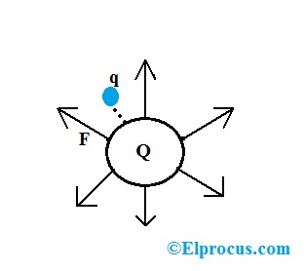Consider an electric field of a given charge body. In order to find electric intensity at a point inside the field we place a test charge having charge ‘ q’. If the electrostatic force applying on a test charge by the charge body is ‘F’ then electric intensity will be s following .

Electric intensity = force/charge

E=F/q

Electric intensity is a vector quantity and directed towards applied force.

# SI UNIT:

When considered in SI units the units of electric field intensity are Newton per coulombs. The electric field intensity is independent of the amount of charge on the test charge particle. It is measured the same all around the source charge regardless of the charge of the test charge particle.

## *GAUSS’S LAW:*

# INTRODUCTION:

The law was first formulated by Joseph-Louis Lagrange in 1773, followed by Carl Friedrich Gauss in 1813, both in the context of the attraction of ellipsoids. It is one of Maxwell's four equations, which form the basis of classical electrodynamics. Gauss's law can be used to derive Coulomb's law, and vice versa. In physics, Gauss's law, also known as Gauss's flux theorem, is a law relating the distribution of electric charge to the resulting electric field.

# STATEMENT:

The total electric flux through a closed body is equal to total charge enclosed by the body divided by ε0.

# FORMULA:

According to Gauss's law, the flux of the electric field →E through any closed surface, also called a Gaussian surface, is equal to the net charge enclosed divided by the permittivity of free space (ϵ0).

***Φ=q/ϵ0***

Proof:

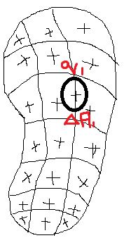Consider a closed body having no of +ve point charges scattered and enclosed .To find electric flux through the body we consider a small sphere ∆A1 having a charge q1 at its centre. The electric flux through ∆A1 will be as following

∆Φe1=q1/ *ϵ****0 [q/ ϵ0=electric flux through a sphere]***

The whole body will be filled with similar spheres that is ∆A2, ∆A3, ……. ,∆An . Their enclosed charges will be q2,q3,……,qn and electric flux will be

∆Φe2, ∆Φe3,……., ∆Φen.

Now the total flux of the closed body is:

Φe=∆Φe1+∆Φe2+∆Φe3+…..+∆Φen

Φe= q1/ ϵ0+ q2/ ϵ0+ q3/ ϵ0+…+ qn/ ϵ0

Φe=q1+q2+q3+…..+qn / *ϵ****0***

**Φe=n∑q / ϵ0 =Q/ *ϵ0 PROOOF***

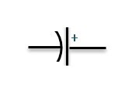CAPCITORS:

**Definition:**

*“The capacitor is a component which has the ability or “capacity” to store energy in the form of an electrical charge producing a potential difference (Static Voltage) across its plates, much like a small rechargeable battery.”*

**Construction:**

In its basic form, a capacitor consists of two or more parallel conductive (metal) plates which are not connected or touching each other, but are electrically separated either by air or by some form of a good insulating material such as waxed paper, mica, ceramic, plastic or some form of a liquid gel as used in electrolytic capacitors. The insulating layer between a capacitors plates is commonly called the **Dielectric.**

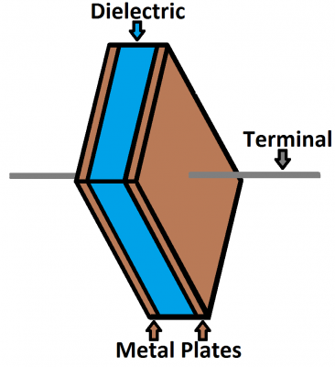The plates are made of a conductive material: aluminum, tantalum, silver, or other metals. They're each connected to a terminal wire, which is what eventually connects to the rest of the circuit.

**Working:**

Electric current is the flow of electric charge, which is what electrical components harness to light up, or spin, or do whatever they do. When current flows into a capacitor, the charges get "stuck" on the plates because they can't get past the insulating dielectric. Electrons -- negatively charged particles -- are sucked into one of the plates, and it becomes overall negatively charged. The large mass of negative charges on one plate pushes away like charges on the other plate, making it positively charged.

The positive and negative charges on each of these plates attract each other, because that's what opposite charges do. But, with the dielectric sitting between them, as much as they want to come together, the charges will forever be stuck on the plate (until they have somewhere else to go). The stationary charges on these plates create an electric field, which influence electric potential energy and voltage. When charges group together on a capacitor like this, the cap is storing electric energy just as a battery might store chemical energy.

**CAPCITANCE:**

Capacitance is the ability of a body (like Capacitors) to hold an electrical charge. In numerical terms, it is the ratio of Electric charge (Q) and Electric potential (V). Mathematically:

Q=CV OR C= $\frac{Q}{V}$

The material of the dielectric even has an effect on how many farads a cap has. The total capacitance of a capacitor can be calculated with the equation:

$$C=ϵr\frac{A}{4πd}$$

Where εr is the dielectric's relative permittivity (a constant value determined by the dielectric material), A is the amount of area the plates overlap each other, and d is the distance between the plates.

**FACTORS AFFECTING CAPACITANCE:**

There are three main factors that affect the capacitance of any Capacitor. They are:

* Area of The Plates (A)
* Distance between the plates (d)
* Relative permittivity of the di-electric (εr)

As the formula shows. The capacitance is **directly proportional** to the permittivity of di-electric and the area of the plates while **inversely proportional** to the distance between the plates.

**Area of the plates:**

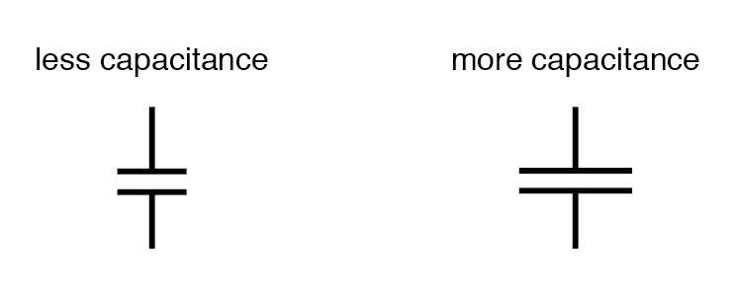

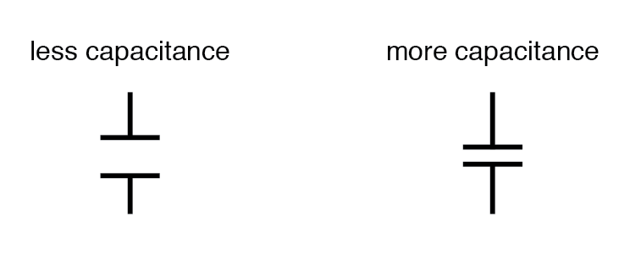**Distance between the plates:**

**:**

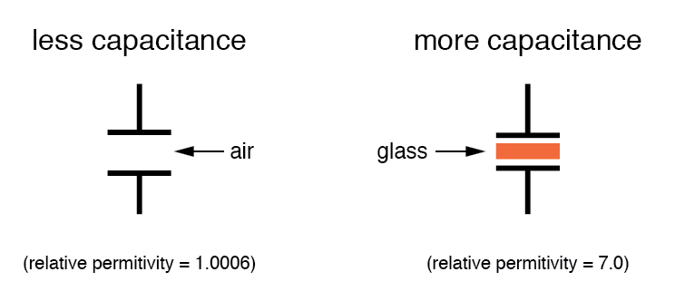

**Permittivity of Di-Electric:**

**CHARGING AND DISCHARGING OF CAPACITORS:**

When a Capacitor is connected to a circuit with Direct Current (DC) source, two processes, which are called "charging" and "discharging" the Capacitor, will happen in specific conditions.

**CHARGING:**

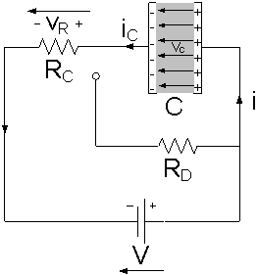The Capacitor is connected to the DC Power Supply and Current flows through the circuit. Both Plates get the equal and opposite charges and an increasing Potential Difference, V is created while the Capacitor is charging. Once the Voltage at the terminals of the Capacitor, Vc is equal to the Power Supply Voltage V i.e. Vc = V the Capacitor is fully charged and the Current stops flowing through the circuit, the Charging Phase is over.

**DISCHARGING:**

A Capacitor is equivalent to an Open-Circuit to Direct Current, R = ∞, because once the Charging Phase has finished, no more Current flows through it. The Voltage Vc on a Capacitor cannot change abruptly.

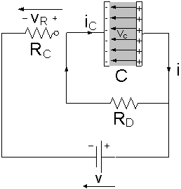When the Capacitor disconnected from the Power Supply, the Capacitor is discharging through the Resistor RD and the Voltage between the Plates drops down gradually to zero, Vc = 0

**TYPES OF CAPACITORS:**

There are following types of Capacitors:

* Electrolytic Capacitors
* Mica Capacitors
* Paper Capacitors
* Film Capacitors
* Non-Polarized Capacitors
* Ceramic Capacitors

**Electrolytic Capacitors:**

The thin metal film layer is used for one electrode and for the second electrode (cathode) a semi-liquid electrolyte solution which is in jelly or paste is used. The dielectric plate is a thin layer of oxide, it is developed electrochemically in production with the thickness of the film and it is less than the ten microns.

**Mica Capacitors:**

This capacitor is a group of natural minerals and the silver mica capacitors use the dielectric.

**Paper Capacitors:**

The construction of paper capacitor is between the two tin foil sheet and they are separated from the paper, or, oiled paper & thin waxed. The sandwich of the thin foils and papers then rolled into the cylindrical shape and then it is enclosed into the plastic capsule. The two thin foils of the paper capacitors attach to the external load.

**Film Capacitors:**

The film capacitors are also capacitors and they use a thin plastic as the dielectric. The film capacitor is prepared extremely thin using the sophisticated film drawing process. If the film is manufactured, it may be metalized depend on the properties of a capacitor. To protect from the environmental factor the electrodes are added and they are assembled.

**Non-Polarized Capacitors:**

The nonpolarized capacitors are classified into two types plastic foil capacitor and the other one is the electrolytic nonpolarized capacitor. The plastic foil capacitor is non-polarized by nature and the electrolytic capacitors are generally two capacitors in the series

**Ceramic Capacitors:**

The ceramic capacitors are the capacitors and use the ceramic material as a dielectric. The ceramics are one of the first materials to use in the production of capacitors as an insulator.

**CAPS NETWORK:**

Caps network is of two types:

* Series Network
* Parallel Network

**Series Network:**

When capacitors are connected in series, the total capacitance is less than any one of the series capacitors’ individual capacitances. If two or more capacitors are connected in series, the overall effect is that of a single (equivalent) capacitor having the sum total of the plate spacing of the individual capacitors. As we’ve just seen, an increase in plate spacing, with all other factors unchanged, results in decreased capacitance.

Thus, the total capacitance is less than any one of the individual capacitors’ capacitances. The formula for calculating series Capacitance is:

$$C_{total}= \frac{1}{\frac{1}{C_{1}}+\frac{1}{C_{2}}+…+\frac{1}{C_{n}}}$$

Where ‘n’ is the number of Capacitors joined.

Capacitors in Series all have the same current flowing through them as

it = i1 = i2 = i3 =…= in.

Therefore each capacitor will store the same amount of electrical charge, Q on its plates regardless of its capacitance. This is because the charge stored by a plate of any one capacitor must have come from the plate of its adjacent capacitor. Therefore, capacitors connected together in series must have the same charge.

Qt=Q1­= Q2 =…= Qn

**Parallel Network:**

When capacitors are connected in parallel, the total capacitance is the sum of the individual capacitors’ capacitances. If two or more capacitors are connected in parallel, the overall effect is that of a single equivalent capacitor having the sum total of the plate areas of the individual capacitors.

$$C_{total=C_{1}+ C_{2}+…+C_{n}}$$

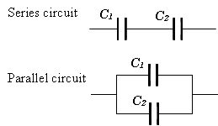The voltage (Vc) connected across all the capacitors that are connected in parallel is **THE SAME**. Then, Capacitors in Parallel have a “common voltage” supply across them giving:

VC1 = VC2 = VC3 = VAB

**APPLICATIONS OF CAPACITORS IN DAILY LIFE:**

A capacitor is a unique device that is capable of storing electrical energy in an electric field. It can also or be a component that has the ability or “capacity” to save energy in the form of an electrical charge. It produces a potential difference (Static Voltage) across its plates, much like a small rechargeable battery. Everyday uses of capacitors in daily life keep adding on the list.

* **Energy Storage:**

Since the 18th century, Capacitors have been storing electrical energy. They generally do not hold a great deal of energy. However, they provide enough power for electronic devices to use when they need additional power or during temporary power outages. For example, large capacitors are included in-car audio systems to provide extra strength to amplifiers when required.

* **Power Factor Correction:**

It is used in electric power distribution. Such capacitors come as three connected as a three-phase Electrical load. Its purpose is to counteract inductive loading from devices like Induction motor, electric motors, and transmission lines to make the pressure appear to be mostly resistive.

* **Used in Sensors:**

Capacitors measure a variety of things, including fuel levels, mechanical strain, and air humidity as sensors. Its structure determines the capacitance of a device. Changes in the fabric are measured as a gain or loss of capacitance. Aspects of a capacitor that are used in sensing applications are the material between them and the distance between the parallel plates. The former is used to uncover mechanical changes such as pressure and acceleration. Every minute changes in the material between the plates are enough to the capacitance of the device.

* **Power Conditioning:**

A critical application of capacitors is the conditioning of power supplies. Besides, capacitors allow alternating current signals to pass but block DC signals when they are charged. They can effectively split these two signal types, cleaning the amount of power.

* **Coupling:**

Capacitors can let AC pass through yet block DC in a process called Capacitor Coupling. It is used in the case of a loudspeaker. Speakers work by converting an alternating current into sound, but they could be damaged by any direct current that reaches them. A capacitor prevents the direct current from damaging the speakers.

* **Tuning:**

Variable capacitors are used when tuning circuits on radio systems by connecting them to an LC oscillator. The capacitor charges and discharges into a wire coil, hence a magnetic field is generated. Once the capacitor is discharged completely, the magnetic field falls while, recharging the capacitor.